Axiom Requisition Copy Service
2869 Jolly Rd, Okemos, Michigan 48864
517.886.5099 – 877.886.5090 toll free – 517.886.4116 facsimile

COMPLETE RECORDS STATEMENT

TO: Joseph E. Kozely

ORDERED BY: Joseph Kozely

OF: Foster, Swift, Collins & Smith, P.C.

FROM: Leah D. Boroski, Account Executive

OF: Axiom Requisition Copy Service

**********

CUSTODIAN: Associated Chiropractic Clinic & Medical Center f/k/a Affiliated Chiropractic

PATIENT: Lorie Ann Strauch

RE: Strauch v. Farm Bureau

FILE NO.: 03770-01403

RECORDS REQUESTED: FROM 07/12/1969 TO PRESENT: ANY and ALL records, including but not limited to any and all documentation or other records generated by any outside source pertaining to Lorie Ann Strauch SSN: XXX-XX-8888, DOB: 07/12/1969.

Please be advised that the above referenced custodian has informed our office that they have provided all the records we requested pertaining to the patient named above. They will not comply with our request to sign an Affidavit of Complete Records or provide a letter stating the same. So we are providing this notice as our completion of this request. Should you have any questions, please feel free to call our office at (877) 886-5090.
Sincerely,
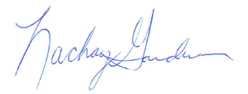
Leah D. Boroski, Account Executive

Order No.: 01-27902-015

